Prototyping Printed Circuit Boards for the Omega Blade

Christian Coffield

ECEN4013

October 18, 2015

## Required components: Alpha/Gamma

|  |  |  |  |
| --- | --- | --- | --- |
| **Component** | **Quantity** | **Footprint** | **Comments** |
| PIC16F1788 | 1 | SPDIP-28 |  |
| N4148 Diode | 2 | SOD323 |  |
| N4148 Diode | 1 | THRU-HOLE |  |
| Programming Header | 1 | 5-Header |  |
| Accelerometer | 1 | 6-Header | Must not be on center of rotation |
| LED Strip Header | 1 | 4-Header | Should be near the top |
| Health RGB Header | 1 | 4-Header |  |
| BJT Transistor | 1 | SOT89 |  |
| Reset Button | 1 | 2-Header |  |
| Battery | 1 | 2-Header | Must be near regulator |
| Regulator | 1 | 3-Header | Must be near PIC |
| Decoupling Cap | 1 | 805 | Must be near PIC's Vdd/GND |
| Resistors | 3 | 1206 |  |
| Interblade Conn. | 1 | 3-Header | Should be near the top |
| IR LED Out | 1 | 2-Header | Should be near the top |
| IR Reception | 1 | 3-Header | Should be near the top |

## Required Components: Beta/Delta

|  |  |  |  |
| --- | --- | --- | --- |
| **Component** | **Quantity** | **Footprint** | **Comments** |
| PIC16F1788 | 1 | SPDIP-28 |  |
| N4148 Diode | 2 | SOD323 |  |
| N4148 Diode | 1 | THRU-HOLE |  |
| Programming Header | 1 | 5-Header |  |
| Accelerometer | 1 | 6-Header | Must not be on center of rotation |
| LED Strip Header | 1 | 4-Header | Should be near the top |
| Health RGB Header | 1 | 4-Header |  |
| BJT Transistor | 1 | SOT89 |  |
| Reset Button | 1 | 2-Header |  |
| Battery | 1 | 2-Header | Must be near regulator |
| Regulator | 1 | 3-Header | Must be near PIC |
| Decoupling Cap | 1 | 805 | Must be near PIC's Vdd/GND |
| Resistors | 3 | 1206 |  |
| Interblade Conn. | 1 | 2-Header | Should be near the top |
| IR LED Out | 1 | 2-Header | Should be near the top |
| IR Reception | 1 | 3-Header | Should be near the top |
| Audio Board | 1 | Custom |  |

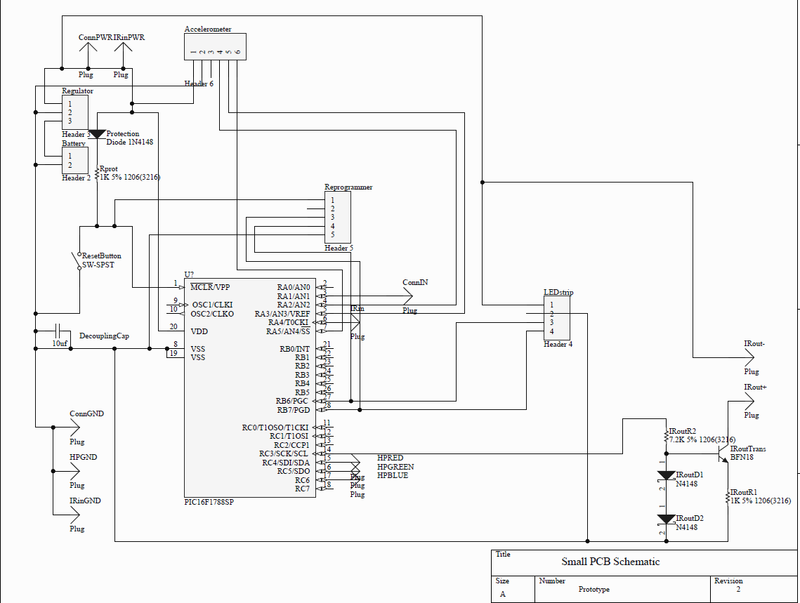

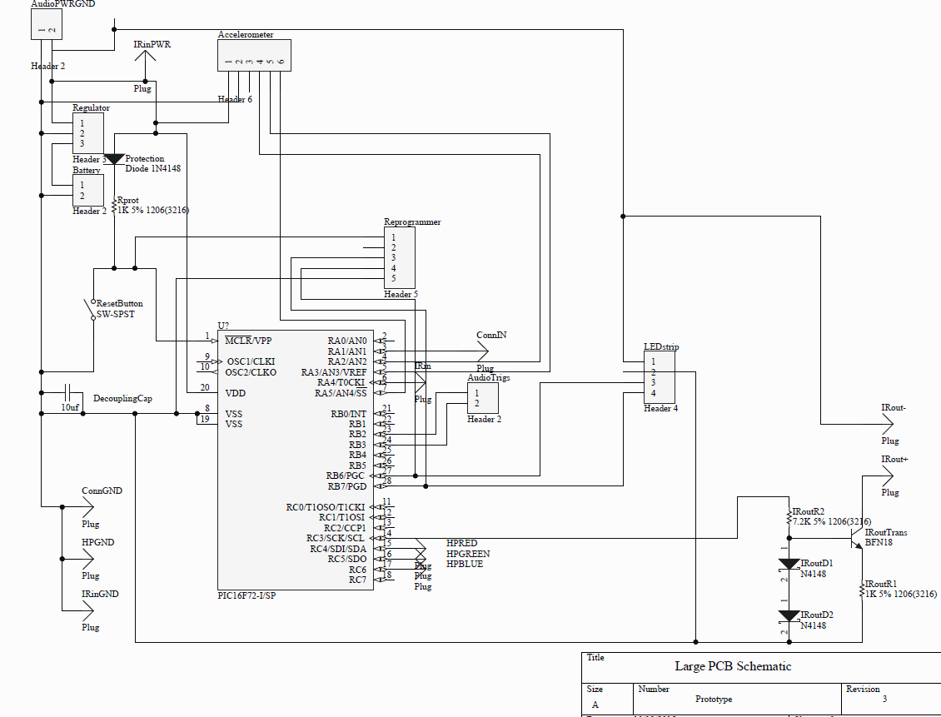

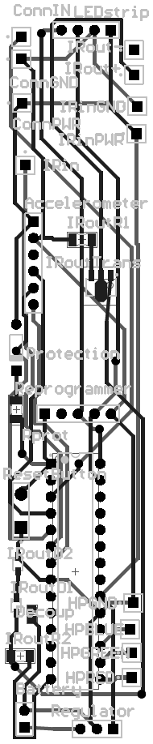 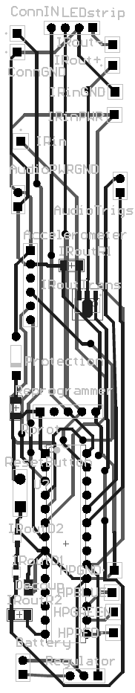

Left: Alpha/Gamma PCB Design

Right: Beta/Delta PCB Design